



**Networks and Operating Systems (CS5001NI)**

**Course Work 1**

Submitted By: Manish Giri

Student ID Number: 15043810

Submitted To: Lecturer: MukeshRegmi

Submission Date: 12/25/2017

Table of Contents

Node reports: Received message counts for all nodes 21

Table: 21

Graph 21

Performance Analysis: 21

Link reports: channel utilization for all links 22

Table 22

Graph 22

Performance Analysis 22

WAN cloud reports: Frame Delay by VC, 23

Table 23

Graph 23

Performance Analysis 23

Frame count by VC, 23

Table 23

Graph 24

Performance Analysis 24

Message and Report response: Message delay for all nodes. 24

Table 24

Graph 25

Performance Analysis 25

Message and Report response: Message Delivered 25

Table 25

Graph 26

Comparision 26

Channel Utilization : 26

Message Delay: 26

Message Delivery: 27

ConclusionFor Task A 27

Introduction 27

Frequency, Low Frequency, High Frequency 27

Frequency Band 28

Frequency Band For Different Services 29

Frequency Band for Radio Communication 29

Frequency Band for Mobile Communication 30

Nepal's Mobile Frequency Allotment 31

Regulatory Provision(Frequency Policy 2069 and 2072) Features and Comparison 31

Comparison of Nepal's Frequency Allotment with Other Country 32

Technology Neutrality and Importance 33

Major Frequency Allocation Scam 33

Conclusion For Task B 34

List of figures

Figure 1 Cloud Interconnection 11

Figure 2 Cloud Diagra 11

Figure 3 Pokhara LAN 12

Figure 5 Protocols Used 13

Figure 4 50 Atm Clients 12

Figure 6 Message Request 14

Figure 7 Teller Reques Size 14

Figure 8 Atm Request Interarrival Probailities 15

Figure 9 Kathmandu LAN 16

Figure 10 50 ATM Cliebnt 16

Figure 11 Protocols Used 17

Figure 12 ATM Request Size 17

Figure 13 Teller Request Size 18

Figure 14 KTM ATM REQUEST 19

Figure 15 London LAN 19

Figure 16 Protocols Used 20

Figure 17 ATM Response Size 20

Figure 18 ATM response Inter-arrival Probabilities 21

Figure 19 Frequency 28

Figure 20 High And Low Frequency 29

Figure 21 Frequency Bands 30

Figure 22 Radio Communication Frequency 31

Figure 23 Frequency For MObile Communication 31

Figure 24 Nepal's Mobile Frequency Allotment 32

Figure 25 Comparision of Nepal's Frequency Allotment with Other Country 33

Figure 26 Frequency Comparision 34

List of tables

Table 1 Node reports: Received message counts for all nodes 21

Table 2 Node reports: Received message counts for all nodes GRAPH 21

Table 3 Link reports: channel utilization for all links 22

Table 4 Link reports: channel utilization for all links GRAPH 22

Table 5 WAN cloud reports: Frame Delay by VC 23

Table 6 Frame Delay By VC 23

Table 7 Frame Count by VC 23

Table 8 Frave COunt by VC Graph 24

Table 9 Message and Report response: Message Delay for all nodes. 24

Table 10 Graph Messege 25

Table 11 Message and Report: Message Delievered 25

Table 12 Message and Report: Message Delievered 26

Scenario: Task A

A mythical company namely IBN bank is a multi-national bank with headquarters in London. The bank is willing to setup two ATM (Automatic Teller Machines) transaction network in Nepal. The two locations in Nepal are Pokhara and Kathmandu. Each network in Nepal consists of 50 ATM transaction nodes plus one single teller giving a total of 51 ATMs each in a LAN. Each LAN is set up using IEEE802.5 10 Mbps token passing standard. The London LAN is also setup using IEEE 802.5 16 Mbps token passing standard with an ATM processing server. Each LANs are connected to the frame relay cloud through a cisco 7010sp, V10.0 router. The tunnel to and from the WAN cloud have a transmission rate of 128 Kbps using sliding window burst type and the links in the WAN cloud have a transmission rate of 256 Kbps.

An estimate is made to support a busy peak of ATM device usage which generates 2 transactions per minute in each ATM. This can be described with an inter arrival time with exponential distribution 0.5 with stream 2. The size of ATM authorization requests can be described by a uniform distribution where the size is evenly dispersed over the range of 50 to 120 bytes with stream 2. All ATM requests are processed at the London server that responds with a message that can be explained with uniform probability distribution where the size is evenly dispersed over the range of 50 to 120 bytes with stream 2. The single teller machines in each LANs (Pokhara and Kathmandu) are generated at an inter arrival time that can be defined with an exponential probability distribution with mean 30 which has a size that can be explained by a uniform distribution where the size is evenly dispersed over the range of 50 to 120 bytes.

Assignment Check ListLAN Description

**KTM LAN**

|  |  |  |
| --- | --- | --- |
| SN | Name | **[✔/×]** |
| 1 | 50 ATM Clients | **✔** |
| 2 | Single Teller Client | **✔** |
| 3 | Token Ring IEEE802.5 10 Mbps | **✔** |

**POK LAN**

|  |  |  |
| --- | --- | --- |
| SN | Name | **[✔/×]** |
| 1 | 50 ATM Clients | **✔** |
| 2 | Single Teller Client | **✔** |
| 3 | Token Ring IEEE802.5 10 Mbps | **✔** |

**London LAN**

|  |  |  |
| --- | --- | --- |
| SN | Name | **[✔/×]** |
| 1 | ATM Processing Server | **✔** |
| 2 | Token Ring IEEE802.5 16 Mbps | **✔** |

**Routing**

|  |  |  |
| --- | --- | --- |
| SN | Name | **[✔/×]** |
| 1 | Cisco 7010sp, V10.0 router | **✔** |

**Link and VC Settings**

|  |  |  |
| --- | --- | --- |
| SN | Name | **[✔/×]** |
| 1 | The tunnel to and from the WAN cloud have a transmission rate of 128 Kbps using sliding window burst type | **✔** |
| 2 | Links in the WAN cloud have a transmission rate of 256 Kbps | **✔** |

**ATM Request Settings for Group Nodes**

|  |  |  |
| --- | --- | --- |
| SN | Name | **[✔/×]** |
| 1 | An estimate is made to support a busy peak of ATM device usage which generates 2 transactions per minute in each ATM. This can be described with an inter arrival time with exponential distribution 0.5 with stream 2. | **✔** |
| 2 | The size of ATM authorization requests can be described by a uniform distribution where the size is evenly dispersed over the range of 50 to 120 bytes with stream 2. | **✔** |

**ATM Message Source Requirements for Teller**

|  |  |  |
| --- | --- | --- |
| SN | Name | **[✔/×]** |
| 1 | The single teller machines in each LANs (Pokhara and Kathmandu) are generated at an inter arrival time that can be defined with an exponential probability distribution with mean 30 | **✔** |
| 2 | The Teller request has a size that can be explained by a uniform distribution where the size is evenly dispersed over the range of 50 to 120 bytes. | **✔** |

**ATM Server Response**

|  |  |  |
| --- | --- | --- |
| SN | Name | **[✔/×]** |
| 1 | All ATM requests are processed at the London server that responds with a message that can be explained with uniform probability distribution where the size is evenly dispersed over the range of 50 to 120 bytes with stream 2. | **✔** |

**Other Configurations**

|  |  |  |
| --- | --- | --- |
| SN | Name | **[✔/×]** |
| 1 | The routing protocol used is TCP-IP Microsoft V1.0 with 10 ms Packetize time. | **✔** |
| 2 | All systems use the routing class defined with a hop count of 65535 with IGRP metric weight (k1) = 1. | **✔** |

**Diagrams**

|  |  |  |
| --- | --- | --- |
| SN | Name | **[✔/×]** |
| 1 | KTM LAN Subnet | **✔** |
| 2 | Pokhara LAN Subnet | **✔** |
| 3 | London LAN Subnet | **✔** |
| 4 | Cloud Diagram | **✔** |
| 5 | Cloud Inter Connection | **✔** |

Cloud Interconnection and its diagram

Cloud Interconnection

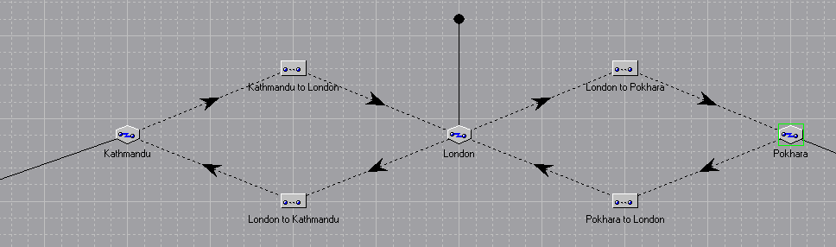

Figure Cloud Interconnection

The diagram shows the cloud interconnection of the Cloud WAN that we have set up that shows the routes of the packets that circulates throughout the connection.

Cloud Diagram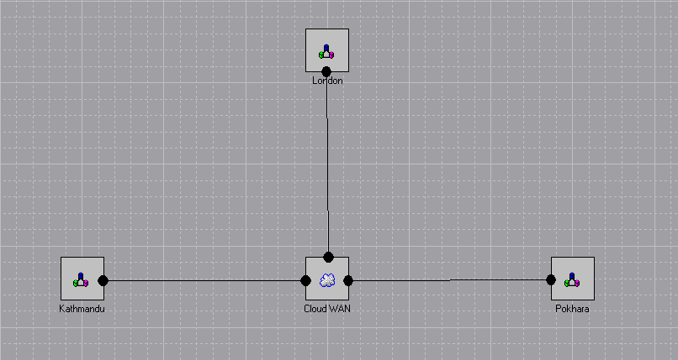

Figure Cloud Diagra

The cloud diagram shows the total setup of the connection of all the LANs that are Kathmandu LAN, Pokhara LAN, London LAN connceted by the CLOUD WAN.

Pokhara LAN

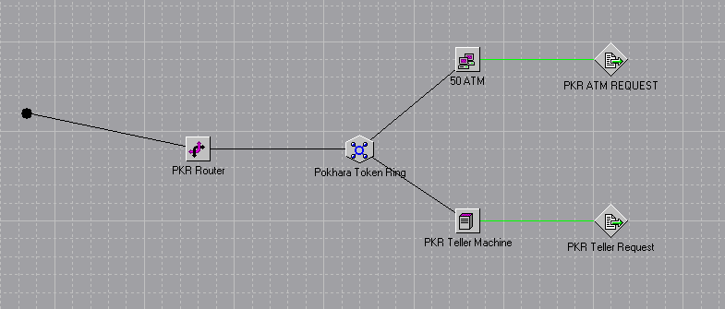

Figure Pokhara LAN

The Pokhara LAN consists of a router that connects the inner LAN to the outter WAN. The router is connected to the Pokhara Token Ring which is followed by 50 ATM attached to the PKR ATM request message source along with the PKR Teller Machine which is attached to PKR Teller Request message source

50 ATM Clients

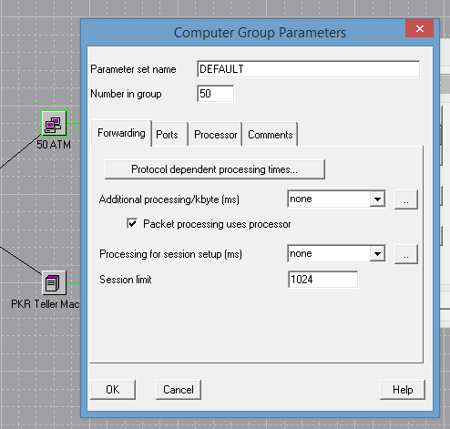

Figure 50 Atm Clients

Using 50 ATM transaction Node in Kathmandu LAN and a single teller which makes 51 ATMs in total.

* Protocols Used:

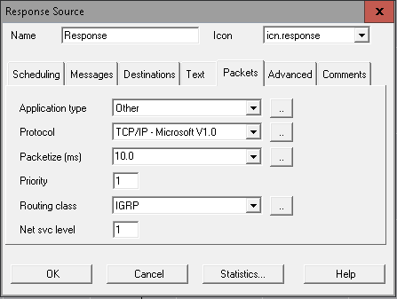

Figure 5 Protocols Used

The protocols used in the response source of are TCP/IP Microsoft V1.0 that have the speed of 10.0 ms and uses routing class IGRP

* ATM Request Size:

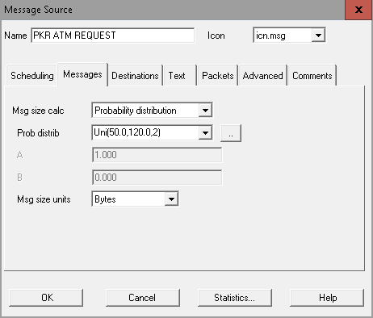

Figure 6 Message Request

The PKR ATM request source uses probability distribution with range (50.0,120.0,2)

* Teller Request Size:

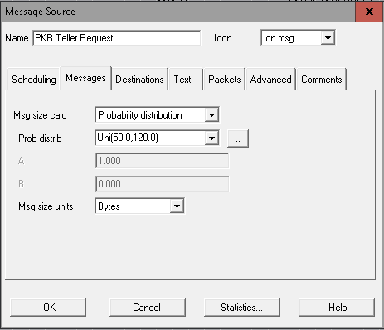

Figure Teller Reques Size

The PKR teller request source uses messege size calculation method as probabilty distribution and is uniformly distributed with range (50.0,120.0)

* ATM Request Interarrival Probabilities:

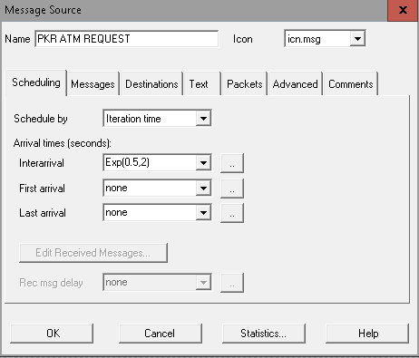

Figure Atm Request Interarrival Probailities

The ATM request is scheduled by iteration time and the interarrival is set exponentially with range (0.5,2)

Kathmandu LAN

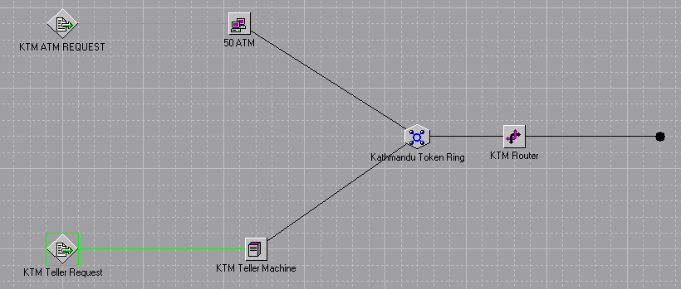

Figure Kathmandu LAN

The Kathmandu lan is set by setting a router connected to the wan on the outer size and the within the LAN its connected to Kathmandu Token Ring which is followed by 50 Atm clients which is connected to the KTM ATM request messege source along with KTM Teller Machine that is connected to KTM Teller Request messege source.

* 50 ATM Clients



Figure 50 ATM Cliebnt

Th 50 ATM clients are set as group in the COMNET which is shown as above .

* Protocols Used:



Figure 11 Protocols Used

The protocols used in the response source of TCP/IP Microsoft V1.0 with the speed of 10.0 ms and uses routing class IGRP.

* ATM Request Size:

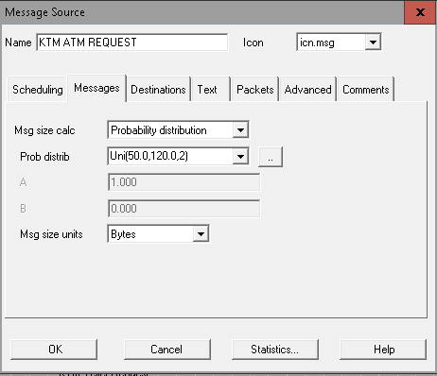

Figure ATM Request Size

The KTM ATM request source uses probability distribution with range (50.0,120.0,2)

* Teller Request Size:

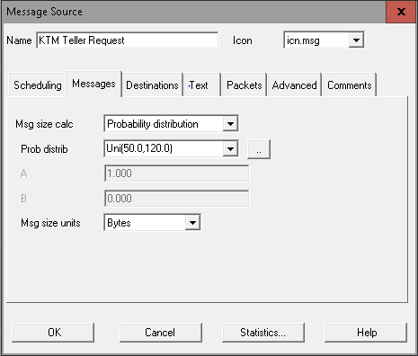

Figure Teller Request Size

The PKR teller request source uses message size calculation method as probability distribution and is uniformly distributed with range (50.0,120.0)

* ATM Request Interarrival Probabilities:

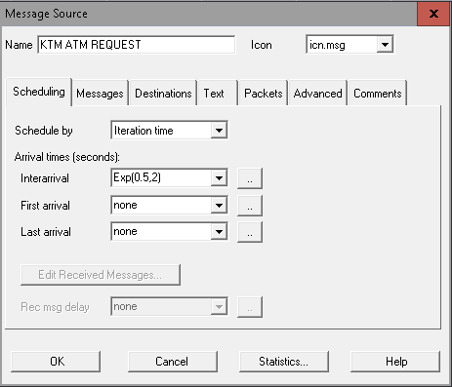

Figure KTM ATM REQUEST

The ATM request is scheduled by iteration time and the interarrival is set exponentially with range (0.5,2)

LONDON LAN

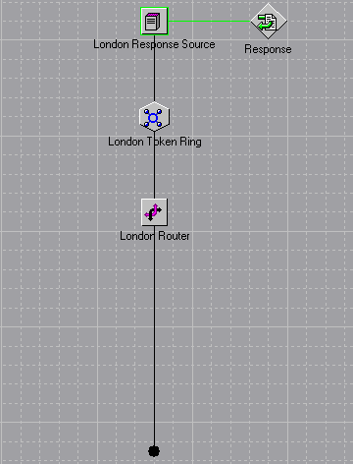

Figure London LAN

The London LAN consists of a router thats connected to the WAN outside and on the inside its connected to the London token Ring followed by London Response Source which is attached to Response source.

* Protocols Used:



Figure 16 Protocols Used

The protocols used in the response source of are TCP/IP Microsoft V1.0 that have the speed of 10.0 ms and uses routing class IGRP.

* ATM Response Size:

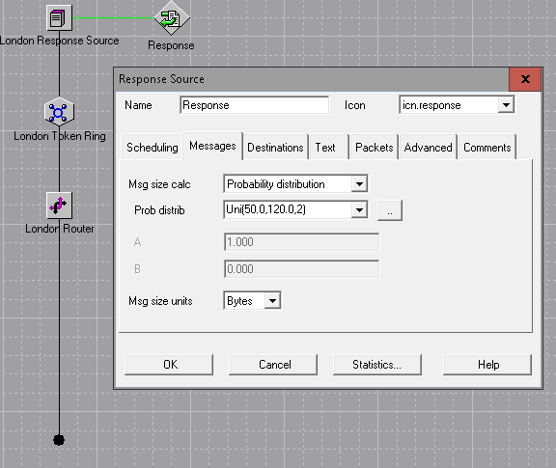

Figure ATM Response Size

The response source on the London LAN usesmessege size calculation as probability distribution which is uniformly distributed with range (50.0,120.0)

* ATM Response Inter-arrival Probabilities:

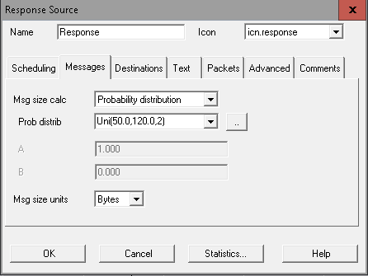

Figure ATM response Inter-arrival Probabilities

Report Discussion

# Node reports: Received message counts for all nodes

## Table:

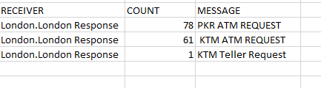

Table Node reports: Received message counts for all nodes

## Graph

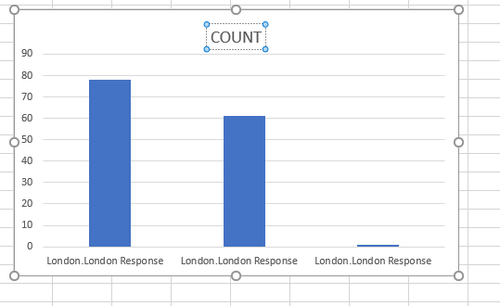

Table Node reports: Received message counts for all nodes GRAPH

## Performance Analysis:

The above bar-diiagram presents the count value of ATM request of KTM PKR and Teller Request of KTM. From the simulation result it is clear that pKR atm Request is more in number where KTM teller request is lower in number.

# Link reports: channel utilization for all links

## Table

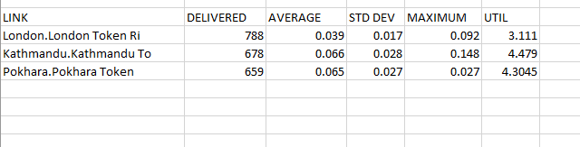

Table Link reports: channel utilization for all links

## Graph

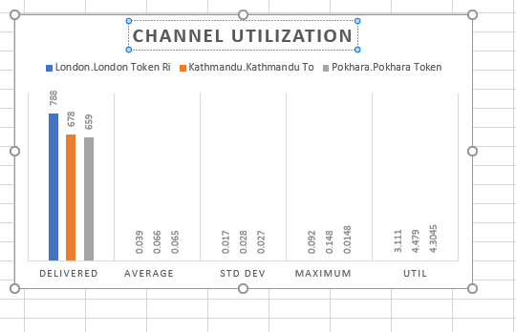

Table Link reports: channel utilization for all links GRAPH

## Performance Analysis

The above bar-diagram presents the channel utilization of all links and by observing the above graph and the table we can see that the highest count is given by London token ring which is located at the London LAN

# WAN cloud reports: Frame Delay by VC,

## Table

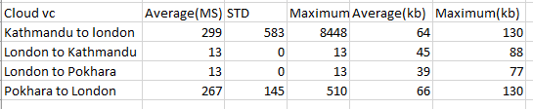

Table WAN cloud reports: Frame Delay by VC

## Graph

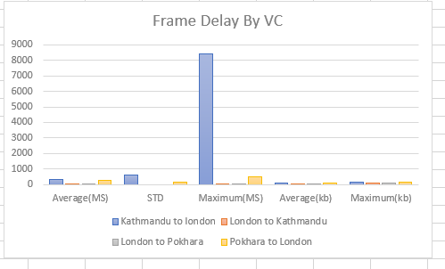

Table Frame Delay By VC

## Performance Analysis

By observing the above table and the graph we can see that the highest frame delay by VC happens from kathmandu to London.

# Frame count by VC,

## Table

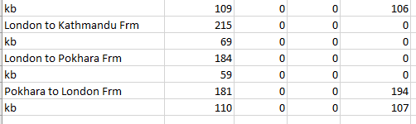

Table Frame Count by VC

## Graph

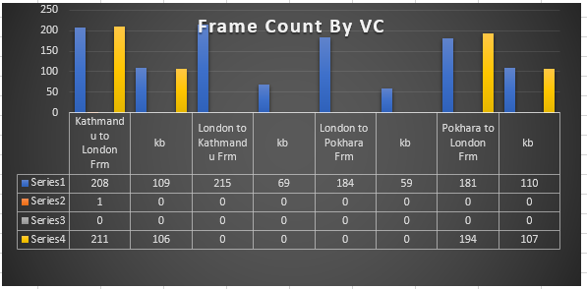

Table Frave COunt by VC Graph

## Performance Analysis

By observing the above tables and graphs we can see that the highest average frame count by VC is from Pokhara to London

# Message and Report response: Message delay for all nodes.

## Table

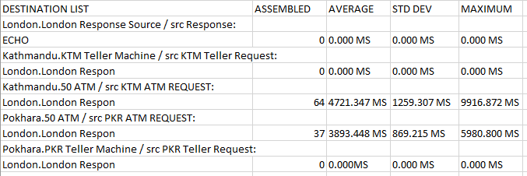

Table Message and Report response: Message Delay for all nodes.

## Graph

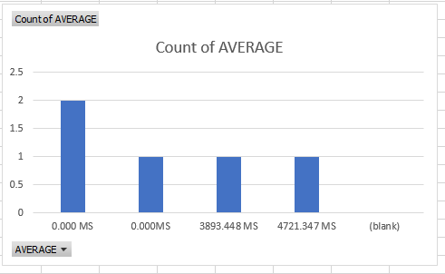

Table Graph Messege

## Performance Analysis

By observing the above tables and the graph we can see that the highest average count messsage delay by london response server

# Message and Report response: Message Delivered

## Table

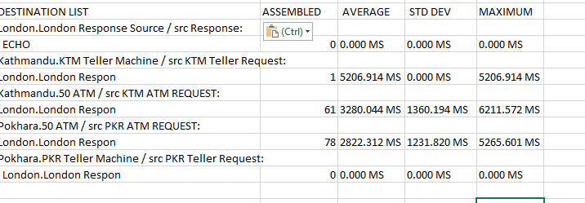

Table Message and Report: Message Delievered

## Graph

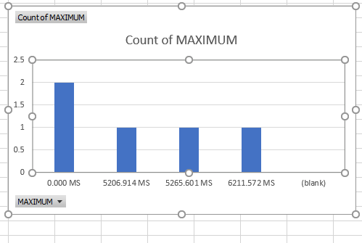

Table Message and Report: Message Delievered

## Comparision

### Channel Utilization :

The channel utilization in P2P(Pokhara LAN) is 6.7808 whereas the channel utilization in WAN(Pokhara LAN) is 3.7138 so it is seen that the utilization percentage in P2P is greater than WAN so P2P is seen to be better than WAN.

### Message Delay:

It is seen that the Average message delay in ATM response in P2P is 31234.441 wheres the average message delay in ATM response source in wan is 43135.26. WAN has the higher message delay so P2P having lower message delay is found to be better than WAN.

### Message Delivery:

It is seen that average message delivery in ATM response of P2P is 25937.55 whereas the same average message delivey in ATM response of WAN is 30109.807 so it is seen that WAN has the higher average message delivery rate.

# ConclusionFor Task A

By using COMNETIII and learning the basics of the software we learned how to set a proper network topology of a required network requirement. As per the requirement of the coursework and by the guidelines provided by our teacher we were able to overcome the task given to us.

Two ATM transaction network in Nepal are set that is Pokhara and Kathmandu. Routers, Links,Lan, ATM’s and Request source are placed. Different parameters are set such as using Cisco 7010sp, V10.0 router, Routing protocol(TCP-IP Microsoft V1.0), Packetize time(10 ms). And Standard Routing class, Request having a size explained by a uniform distribution where the size is evenly dispersed over the range of 50 to 120 bytes etc. making the transactions process complete.

**Task #B**

# Introduction

The main aim behind the completion of this coursework is to understand about the different frequency bands used in the telecommunications.

# Frequency, Low Frequency, High Frequency

* Frequency

The frequency of a signal voltage is measured in cycles per second. One hertz is one complete cycle per second. While higher frequency can mean a faster system, a truer measurement of communication speed is bit rate.

* Low Frequency

Low frequency is a radio frequency band or a frequency lying between 30 KHz to 300 KHz. Low frequency is used by the submarine for the underwater communications.

* High Frequency

Highfrequency(HF) is an electromagnetic frequency defined for radar and radio communications by the International Telecommunications Union (ITU).It operates in a range of three to thirty MHz. High frequency is very popular among military and government communications, amateur radio, radar communications and global safety system communications.

# 

Figure High And Low Frequency

# Frequency Band

Frequency band is an interval in the frequency domain, bounded by a lower frequency and an upper frequency. The frequency range or band of a system is the range over whicj it is considered to provide satisfactory performance. This figure represents the different frequency bands.

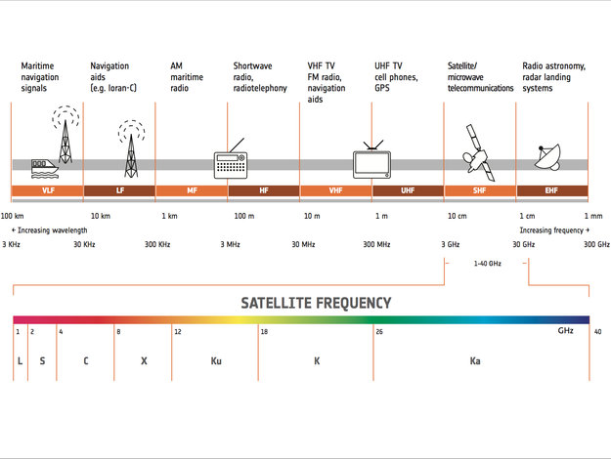

Figure Frequency Bands

# Frequency Band For Different Services

## Frequency Band for Radio Communication

RF is the lowest portion in the electromagnetic spectrum familiar as a medium of analogue and modern digital wireless communication system. It spreads in the range between 3 KHz and 300 GHz.

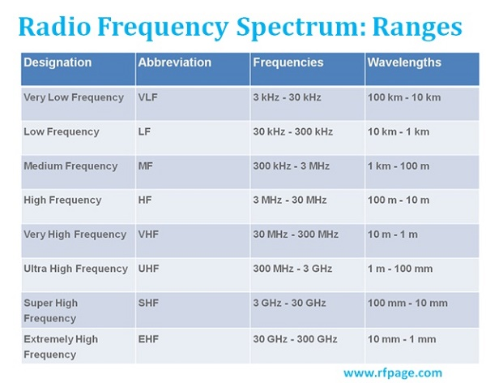

Figure Radio Communication Frequency

## Frequency Band for Mobile Communication

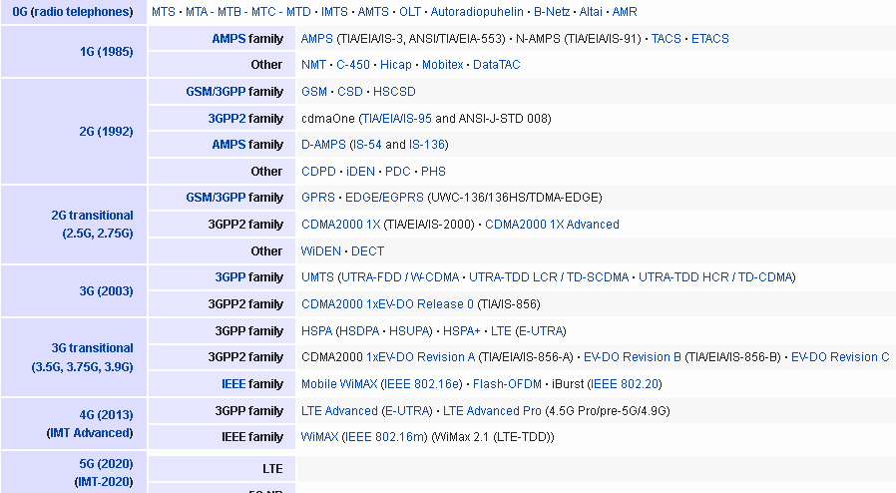

Figure Frequency For MObile Communication

Cellular frequencies are the sets of frequency ranges within the ultra high frequency band that have been assigned for cellular-compatible mobile devices, such as mobile phones, to connect to cellular network

# Nepal's Mobile Frequency Allotment

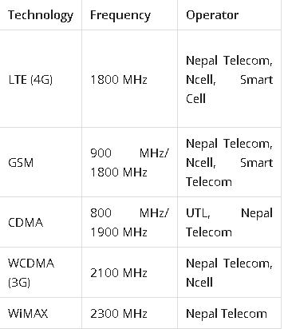

Figure Nepal's Mobile Frequency Allotment

It is the regulator body (Nepal Telecommunication Authority) which provides chunk of frequency in different frequency bands to the Mobile operators. Mobile communication has started in Nepal from 1999 with the launching of GSM service by Nepal Telecom.

# Regulatory Provision(Frequency Policy 2069 and 2072) Features and Comparison

Frequency Policy 2069

Principle include-

* Auction as a method for determining the spectrum prices and assignment in new bands including 3G,
* Technology neutrality while assigning spectrum.
* Prohibition on spectrum trading.
* Spectrum capping introduced.
* Spectrum hoarding discouraged by applying higher prices.

The policy has declared the following as the maximum limit for any operator in a given band.

|  |  |  |
| --- | --- | --- |
| SN | Frequency Band | Maximum Bandwidth |
|  | Possible Technology | (MHz) |
| 1 | 800 MHz/CDMA | 2 *5 |
| 2 | 900 MHz/GSM | 2*9.6 |
| 3 | 1800 MHz/GSM | 2*15 |
| 4 | 2100 MHz/GSM | 2*10 |
| 5 | 2300 MHz/BWA/IMT Advanced | 30 |

Frequency Policy 2073

Objectives:

* To create level playing fields among telecommunications.
* To implement technology neutrality in Nepal.
* To bring more spectrum efficient technology like 4G in Nepal.
* To promote tele-communication, maximize the usage of limited radio frequency.
* To implement auction in new frequency bands and maximize the revenue from spectrum to government.
* To fix total bandwidth in new and existing frequency bands and assign minimum spectrum and Maximum bandwidth (with or without merger).

## Comparison of Nepal's Frequency Allotment with Other Country

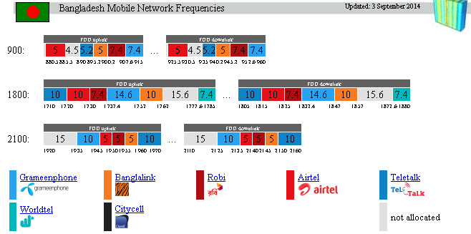

Figure Comparision of Nepal's Frequency Allotment with Other Country

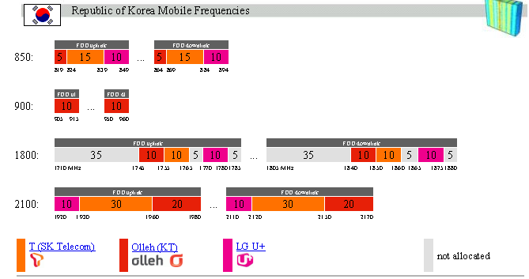

Figure Frequency Comparision

# Technology Neutrality and Importance

The basic concept of Technology neutrality resulted in a number of benefits for consumers, including the deployment of high quality, innovative, cost-effective telecommunications services and increased connectivity even in the most rural and remote portions of the globe. For example, in the mid-2000s, the Federal Communications Commission (FCC) adopted location accuracy requirements for mobile 911. The FCC adopted broad requirements on accuracy, but refrained from adopting what technology a service provider had to use to meet those requirements (e.g., GPS, triangulation capabilities).

Importance:

* Technology neutrality defines the scope of regulation.
* It is used in standards intended to limit undesirable effects.
* It can be used to nudge the market in a certain direction that is considered desirable by policy makers.

# Conclusion For Task B

This task mainly includes reasearch work about the frequency bands of different bands of the medium such as radio communications and mobile communications.The task also included the research work of frequency bands of mobile communication as well as the comparision of the frequency bands of other countries. After all the research works that were guided by our coursework we were able to prepare a full report of the frequency bands which includes the reports of the current frequency bands of our country as well as the the other countries. We were also able to evaulate and make a recommendation for the current frequency allocation of Nepal . We were also able to find out the mass frequency allocation scam that has happened in the past.

Appendix

